Title: Assessment of wildland fire management in South Africa

David Flores, Desmond Lartey, Louis Fleming, and other SA fire managers

Citation: Flores, David; Lartey, Desmond, Fleming, Louis, and other SA fire managers. 2024. Title. Gen. Tech. Rep. RMRS-GTR-xxx. Fort Collins, CO: U.S. Department of Agriculture, Forest Service, Rocky Mountain Research Station. xxx p.

# Acknowledgments

This study would not have been possible without the participation of South African wildland fire managers and USDA Forest Service International Programs, who shared their perspectives of wildland fire management. We also thank the following reviewers for their insightful comments on earlier drafts of this report: Cathelijne Stoof, Assistant Professor, Department of Environmental Sciences, Wageningen University, the Netherlands; Joseph Harris, Acting Director, Innovation and Organizational Learning, USDA Forest Service; and Peter Moore, Food and Agricultural Organization of the United Nations.

**Authors**

**David Flores** is a Research Social Scientist with the Human Dimensions Program of the USDA Forest Service, Rocky Mountain Research Station in Fort Collins, Colorado. He completed his B.A. degree in sociology at the University of California, Berkeley, and M.A. and Ph.D. degrees in sociology at the University of Michigan. His research focuses on the social and cultural characteristics of decision making and natural resource management.

**Desmond Lartey** is

**Louis Fleming** is a Smokejumper and Program Specialist with the USDA Forest Service, International Programs. He has an M.S. in Forestry from the University of Montana.

**SA fire managers**

Cover photo:

**Contents To be updated upon completion**

Acknowledgments i

Summary v

Introduction 1

Purpose of this Study 1

Background 1

Structure of this Report 3

Methodology 4

Findings and Analysis 7

Outreach and Relationship Building 7

Communication Challenges 8

Striving for Meaningful Outreach 10

Meaningful Consultation 12

Developing Diverse Partnerships 13

Forest Service Tribal Liaisons 14

The San Francisco Peaks 17

Turning Challenges into Opportunities 18

Collaboration 19

Perceptions of Exclusion from Forest Service Programs 20

Perceptions of Inclusion in Forest Service Programs 21

Reserved Treaty Rights Lands Program and the Pacheco Canyon Prescribed Burn 22

Reserved Treaty Rights Lands Program and the Greens Peak Project 24

A Broader Look at the Reserved Treaty Rights Lands Program 25

Collaboration Beyond Fuel Treatments and Forest Restoration 28

Moving Forward with Collaborations 29

Intercultural Growth Within the Forest Service 32

Conclusions 33

References 39

**Abstract (David)**

This report examines the state of contemporary perceptions of wildland fire managers in South Africa. The perspectives of wildland fire managers in South Africa are presented in an effort to provide the USDA Forest Service and the Government of South Africa with a comprehensive depiction of wildland fire management. This report identifies…

The findings are organized into…

**Keywords:** South Africa, wildfire, bushfire, fire management

# summary (David)

The general purpose of this report is to examine the state of contemporary contemporary perceptions of wildland fire managers in South Africa. Our investigation proceeds not through an evaluation of current policies and practices but, instead, by providing the reader access to the perspectives of wildland fire managers on… Our goal is to provide the USDA Forest Service and South African Government (and anyone else) with a comprehensive depiction of wildland fire management perspectives. Learning about the perspectives of employees doing the work of wildland fire management opens meaningful lines of research and practice that may not otherwise be apparent. This analysis of wildland fire management also holds the possibility of…

This General Technical Report identifies the 5 R’s of Integrated Fire Management…

1. Review and analysis: define analyze, and track fire activity and impacts
2. Risk Reduction: strategies for fire use, ignition, reduction, and impact mitigation
3. Readiness: Preparedness to manage fires
4. Response: Fire response operations
5. Recovery: Post fire repair, loss reduction, and community assistance

# Introduction (david)

## Purpose of this Study

The purpose of this study is to provide an assessment of wildland fire management in South Africa, specifically within the framework of Integrated Fire Management (IFM). This study proceeds not through an evaluation of current policies, but instead by providing the reader access to the perspectives of wildland fire managers working in the context of South Africa. Our goal is to provide the USDA Forest Service and South African government (and anyone else) with a comprehensive depiction of wildland fire management in South Africa. Learning about the perspectives of wildland fire managers opens meaningful lines of research and practice that may not otherwise be apparent.

## Background (2 pages) (David)

Wildland fire-related programming is in high demand throughout the world, and Africa is no exception. Africa has the highest portion of fire-prone ecosystems in the world, and climate change is creating warmer, drier conditions (CITE SOURSE). When measured by satellite, annual burned area in Africa accounts for approximately 67% of the global total. Impacts are more difficult to measure, but run the gamut, both positive and negative (CITE MATT JOLLY).

Integrated Fire Management (IFM) recognizes that fire is a natural and necessary ecological process in many ecosystems, playing a crucial role in maintaining biodiversity, nutrient cycling, and overall ecosystem health. However, it also acknowledges that fire can pose risks to human life, property, and livelihoods. IFM emphasizes the integration of various strategies and tools to effectively manage fire in a way that minimizes negative impacts while promoting positive impacts, such as ecological health and community safety. This includes acknowledging fire’s positive and negative impacts from ecological, economic and socio-cultural perspectives and the trade-offs that inevitably result from decisions and actions.

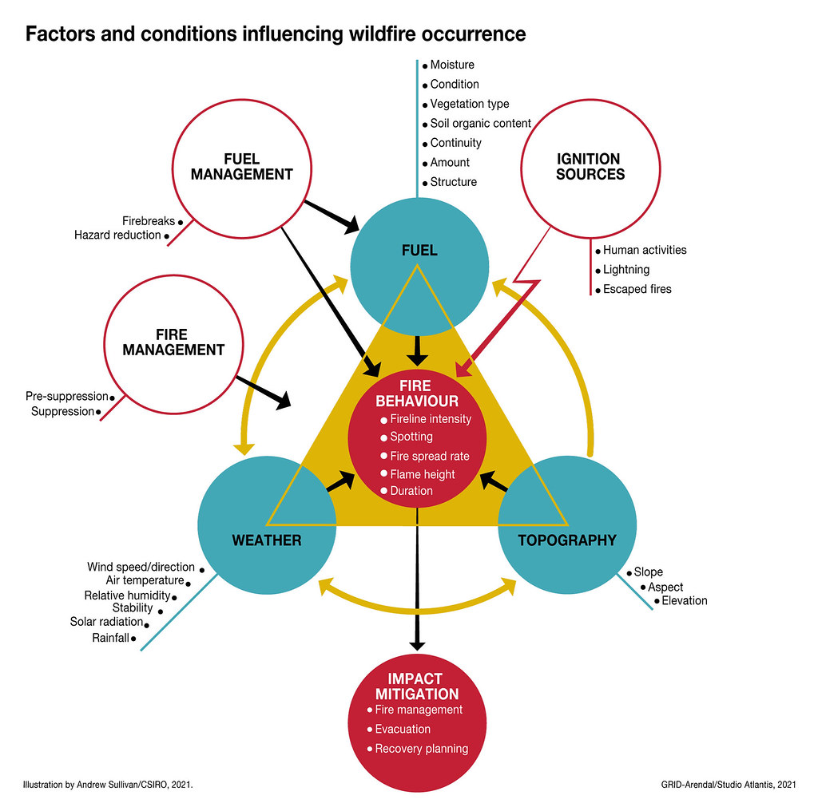

## Structure of this Report (David)

This General Technical Report identifies…

IFM activities are categorized in one of five groups. The groupings help operationalize and compartmentalize fire management actions.

# Methodology (desmond)

Describe the tool that was used and how it was used.

We utilized…

# Findings and Analysis (Desmond)

## Review and Analysis

Include visualizations and write ups from power point. I can add to the writing after you decide which visualizations and points that you think are important to make.

## Risk Reduction

Include visualizations and write ups from power point. I can add to the writing after you decide which visualizations and points that you think are important to make.

## Readiness

Include visualizations and write ups from power point. I can add to the writing after you decide which visualizations and points that you think are important to make.

## Response

Include visualizations and write ups from power point. I can add to the writing after you decide which visualizations and points that you think are important to make.

## Recovery

Include visualizations and write ups from power point. I can add to the writing after you decide which visualizations and points that you think are important to make.

# Discussion (David)

David will write this up after background and results are written.

# Conclusion (David)

David will write this up after background, results and discussion are written.

# References